### ****E1 Mode Frame Structure (Layer 2) with Bit Details & Diagram****

The **E1 frame** is a **basic unit** in **PDH (Plesiochronous Digital Hierarchy)** and has a **total data rate of 2.048 Mbps**. Each frame is **256 bits long** and consists of **32 time slots (TS0 - TS31)**, with each time slot containing **8 bits (1 byte)**.

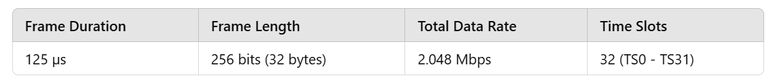

### ****E1 Frame Time Slots & Bit-Level Breakdown****

Each **E1 frame** consists of **32 time slots**, each **8 bits wide**. Here’s the breakdown:

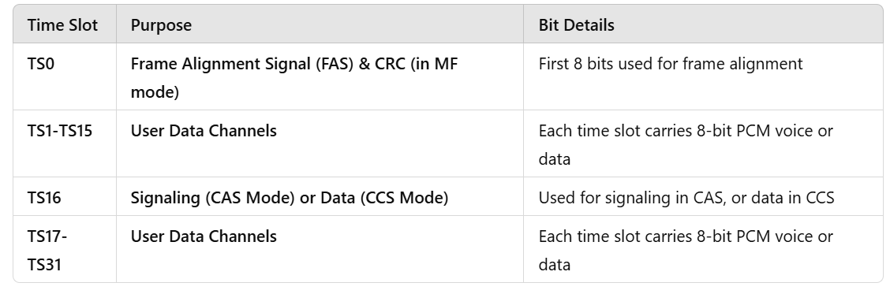

### ****E1 Frame Bit-Level Diagram****

Each frame consists of **256 bits** (32 time slots × 8 bits). Below is a **bit-wise representation** of an **E1 frame**:

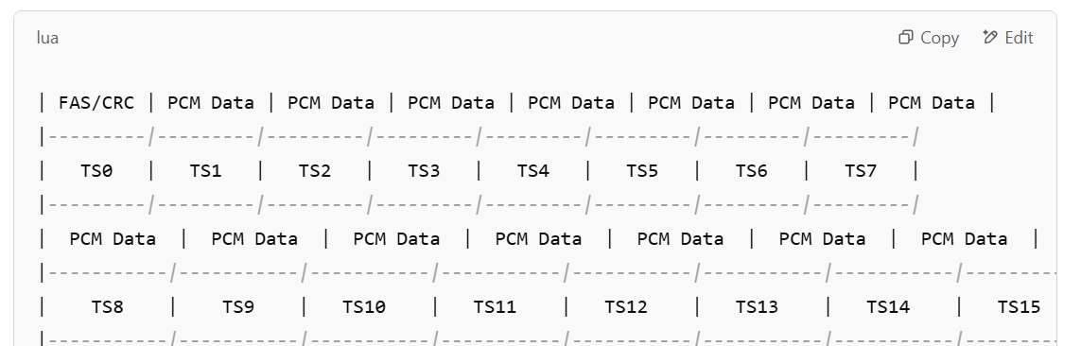

### ****Detailed Description of Key Time Slots****

**TS0 (Time Slot 0 - Frame Alignment & CRC)**

* 1. Used for synchronization.
  2. In **frame-aligned (FAS) mode**, it contains a repeating pattern for alignment.
  3. In **multiframe (MF) mode**, it carries a **Cyclic Redundancy Check (CRC-4)**.

**TS1 - TS15 & TS17 - TS31 (User Data)**

* 1. These **carry voice/data** encoded using **PCM (Pulse Code Modulation)**.
  2. Each **time slot carries an 8-bit sample** of a voice channel (64 kbps per channel).

**TS16 (Signaling or Data)**

* 1. **CAS Mode (Channel Associated Signaling)**: Carries **signaling information** (such as call setup and teardown signals).
  2. **CCS Mode (Common Channel Signaling)**: Used for **data transmission** (e.g., ISDN, SS7).

### ****E1 Multiframe Structure (When CAS is Used)****

* **E1 consists of 16 frames per multiframe** (total **512 time slots**).
* In **multiframe mode**, TS16 follows this structure:

| **Frame No.** | **TS16 Content** |
| --- | --- |
| Frame 1 | A-bit for signaling |
| Frame 2 | B-bit for signaling |
| Frame 3 | C-bit for signaling |
| Frame 4 | D-bit for signaling |
| Frame 5-16 | Spare bits or additional signaling |

## ****E1 Frame Summary****

1. **E1 frame is 256 bits long (32 time slots × 8 bits).**
2. **TS0 is reserved for frame alignment & CRC.**
3. **TS16 is used for signaling in CAS mode.**
4. **Each user channel (TS1-TS15, TS17-TS31) carries 8-bit PCM voice/data (64 kbps per channel).**
5. **Total frame duration: 125 µs.**
6. **Multiframe structure used for CAS signaling.**